Regulated Information
August 22, 2025 – 8:30 CEST

Publication relating to a transparency notification
- Summary of the notification
Llama Group SA (“Llama Group”) announces that it received a transparency notification from Maxximum SA, reference shareholder of Llama Group controlled by Alexandre Saboundjian. This notification does not result from an acquisition or disposal of shares, but rather follows the capital increase carried out on July 10, 2025.
Indeed, on July 10, 2025, Llama Group announced, in accordance with Article 14 of the Law of May 2, 2007 on the disclosure of major shareholdings in issuers whose shares are admitted to trading on a regulated market, that it had completed a private placement capital increase of €1,000,000, raising the Company’s share capital from €29,859,118.30 to €30,859,119.10 through the issuance of 1,666,668 new ordinary shares at a subscription price of €0.60 per share.
As a result of this capital increase, the total number of voting rights (the denominator) used as the basis for threshold calculations was adjusted to 19,491,252.
As a reminder, for companies listed on Euronext Growth, the relevant shareholder threshold levels are: 25%, 30%, 50%, 75%, and 95%.
Accordingly, Maxximum SA, has crossed below the 50% threshold of voting rights in Llama Group as of the date of the capital increase, and now holds 45.86%.
- Content of the notification
- Reason for the notification: Passive crossing of a threshold
- Notification by: A parent company or a person exercising control
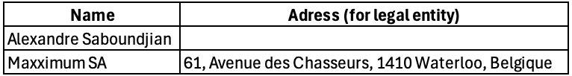
- Notifying person:

- Date of threshold crossing: 10 July 2025
- Threshold crossed: 50%
- Denominator: 19,491,252 voting rights
- Notification details:
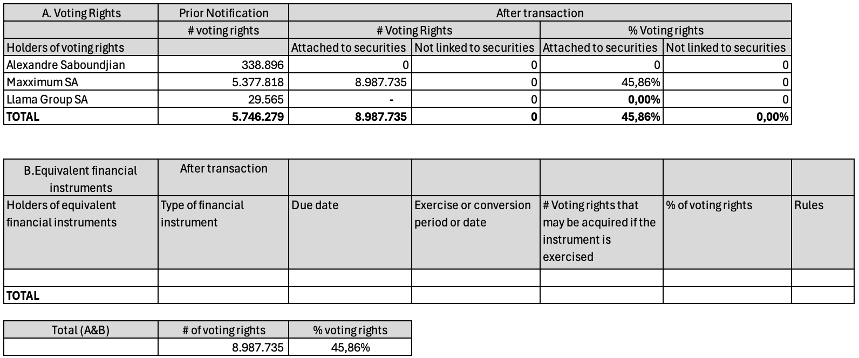
- Chain of controlled undertakings through which the holding is effectively held: Alexandre Saboundjian controls Maxximum SA
- Content of the notification
None

Next Meeting
August 28, 2025 – Extraordinary General Meeting

CONTACTS
Investors Relations
Olivier Van Gulck
investors@llama-group.com

About Llama Group
Llama Group is a pioneer and leader in the digital music industry. With extensive expertise across various sectors, the group owns the iconic Winamp platform, the Bridger copyright management company, and the Jamendo music licensing company. Llama Group's ambition is to build the future of the music industry through sustained investment in a range of innovative solutions and in the talent and skills of people who love music. The group stands by its brand values: empowerment, access, simplicity, and fairness. Winamp's vision is a world where a cutting-edge music platform connects artists and their fans like never before. Bridger's mission is to support songwriters and composers by providing a simple and innovative solution for collecting royalties. Jamendo enables independent artists to generate additional income through commercial licenses. Finally, Hotmix offers a bouquet of more than sixty thematic and free digital radio stations.

